Intro
In this project about development and use of databases, I have designed a small web page, that shows the information on movies and TV-series'. The web page is to show information on actors, roles of the actors, producers and other staff, while also showing general information on the movie.
The goal of the web page, is to further more, give users of the web page the ability to make a personal list of movies and TV-series' they have watched, want to watch and are watching currently. Thereby giving users of the web page a way of tracking their progress with what they are watching.
Mymovielist, as the web page has been named, is the result of three part case studies which make the basis of this project. The web page has been designed with the help of an analysis part, which creates an overview on the functions, which the web page is to have, a programming part, where the functions are programmed and a user interface part, which is to bridge the database with the webpage, giving the human users a way of interacting with the database.
The web page is tested towards two ends; whether it works or not and whether the user interface communicates to the users in an understandable way, what the developer had in mind.
Towards this goal, I have used Object oriented analysis and design (OOAD), The Unified Process (UP), SQL, PHP, HTML and CSS programming.

Problem formulation
When looking at the current major web pages, for movie information, one will see several pages that supply information on movies and TV-series', including user opinions and user ratings. This goes for anything animated and shown in the cinema or on TV. While this can help many decide on whether they want to watch a TV-series or movie, it doesn't give them the ability to keep track of what they have already seen or might want to watch at a later date. At least not without typing down a list in a document, adding a lot of bookmarks for the series/movies or trying to memorize all you have watched and want to watch. All options would seem like halfway solutions as:
- By documenting it, you will need to keep a long list in a document, which you need to continuously update by replacing or adding information, this goes especially for tv-shows.
- By using bookmarks, you have a long list of links, which you will need to open seperately, to track the things you are watching.
- Making a mental note of how far you are with several different tv-shows and movies and also noting how many you have watched and plan to watch, can take up a lot of personal memory, while at the same time being easy to forget.
For these reasons, the goals for this web page are:
- Give users the option to see information on movies and TV-shows
- Give users the option to track their progress with movies and TV-shows
- Doing the above while providing an easy to use interface with high usability.
These goals and problems I will attempt to solve in this report, with the help of the tools mentioned earlier.

Method description
In the course of designing Mymovielist, knowledge from OOAD, taught to us in the second semester and UP, an agile method, taught to us in the current semester, has been needed. The report is structured, so that UP is intermixed with the OOAD process, to bring in an agile perspective to the design and programming of Mymovielist.

OOAD
To describe the use of the web site, in a more defined manner and to give an overview of what functions it will contain, while also giving both the reader and the developer an understanding of how the web site will work, a system definition is made. The system definition gives an overview of the decisions made when working with OOAD to figure out what is needed and shows the basic considerations I have done using the tools provided by OOAD.

Unified Process

Field of problem
By personal use of the websites http://www.myanimelist.net, http://www.imdb.com and talking with users of both, I gain an understanding information on that is wanted on Mymovielist. This information is then used to clarify the functions needed on the web site.
With the intention of giving an overview on how the web site is to be built, a number of classes are then made. These classes are based on the system definition and help us create the wanted overview.
An actions table is also made, to show what actions affect the individual classes, from which we get a better insight into the classes.
Status diagrams is another thing I use, to describe the different states that an object can have and what actions can change the state of the object.
The use of this tool gets me an overview on how different objects on the web site acts and what attributes the different classes contain.

Field of application
Actor specifications is another thing made for the actors existing in the field of application. I use this to gain an understanding of who the actors working with the web site is and how they work with it.
From the actor specifications I can then form usage patterns, which furthers the understanding of how users interact with the web page.
To get an overview of what functions are used by the actors through interaction with the web site in different usage situations, I have made a functionslist, which splits up functions by type and complexity, with the complex descriptions described in a more detailed fashion.
In the work with the menu's, I have set requirements based around the requirements the users will have for it.
After that I have used a navigation diagram, to gain an overview on what elements should be on the menu and what elements should appear as links to sub pages on the web site. This to get a plan on how interaction with the web site will work.

Requirements
To clarify who the systems users are, I have made been deciding the stakeholders.
To gain a better understanding of the users of the web site, I have used personas, which can help me gain a clearer picture of what usergroups the web site is made for.
Adding to this we have scenarios, with the personas, which gives a better perspective to what activities the system is to support.
All of this is used to give me ideas as to what the users wish the web site can do and help me get a better idea of how it is to be designed.

Generating design
While choosing which elements need to be on the web site is done through the OOAD case, there is still a need to decide how these elements are to be placed.
To do this I look back at the 2 original web sites and do a heuristic usability, as accordance to Jakob Nielsens Heuristic test model. With this done, we then analyze on the problematic areas of the design and from there on try to improve them. This I do on image sketches of possible design solutions for the web page.

Implementing design
The user interface for this web site is built by using CSS elements in a php+html coded front. This is made with mostly the programs Notepad++ , Microsoft SQL Server 2008 Management Studio and with PhpMyAdmin, which is also used to make the database, from which the web site is to pull its information from.
Images used in the user interface are made with the image manipulation programs Photoshop and Paint.Net.

Evalutation
Under the title of “generating design” I describe how I will use the heuristic model of Jakob Nielsen to choose a design. This same method will be used to evaluate and choose the final design, to show how the new design improves the usability and thereby the user experience of the web site.

Realization of the finalized model
In the last bit of the report I describe in detail, how I with the help of the aforementioned programs, build the web site. This realization will go through iterations to improve the code, which will be done both after testing and when code is found that can be improved.
SQL code will be tested in phpmyadmin, while php code only can be tested through use of it.

Casedescriptions

OOAD
Object oriented analysis and design, as is the full name of the abbreviation OOAD is the method I use to figure out what functions and objects are to be on the web site. It reflects the decisions I made in designing the web site layout, while also containing an analysis document. The case is based on the material in the book “Objekt Orienteret Analyse & Design”, [Mathiassen]
To grant a better overview of the sequence which the OOAD is done, the analysis is split into blocks that each describe some of the many considerations I did, while designing the layout of the web site. Below is a list showing the blocks, the analysis is split into.
- Analysis of the field of the problem area
- Analysis of the field of application
- Design of architecture
- Design of objects and components

Unified Process

Web site analysis and design

Definition of the Web Site (system definition)
The Mymovielist website is to handle information on movies and tv-shows, giving users the ability to look up this information. At the same time it is the wish that the web site is to help users of it, to list this information on a personal list, from which they can see whether this is a tv-show or movie they have already seen (a completed list), want to see at some point or is currently following (plan to watch and watching list) or shows they have stopped watching or put on halt for any given reason (on-hold and dropped list). The goal is to make an easy to use web site, giving users easy access to whatever information on a movie or tv-show, while also giving them an easy to use function to add a movie or tv-show to their personal list. At the same time, it should be easy to change the status of an item on their personal list. e.g. the user wishes to move a tv-series from watching to completed or simply add to the list that they have watched one more episode of a tv-series, they are currently watching.
Administrators of the website should in the same manner be able to add info on a new movie or tv-series to the database and website.
The layout of the web site is to be designed with PHP, CSS and HTML and the database in SQL. It is the principle, that it should be easy to find the information on a movie you are looking for and it is the principle, that it should be easy to add the movie to a personal list.
a system definition is made. The system definition gives an overview of the decisions made when working with OOAD to figure out what is needed and shows the basic considerations I have done using the tools provided by OOAD.

Field of problem

Classes
Classes. A class is the definition of the behavior and properties of one or more objects within your system. A class binds the data (attributes) of an object to the behavior (operations) that it can perform.

Classes

Users:
Users is the class, from which admininstrator and default user inherit their rights.

Admin
The administrator is to control the information displayed on the web site, it is therefore the thought that the admin will be able to add new information to web site, add new movies and new tv-shows to the database, while also being able to update or correct information already existing in the database for the web site.

Default user
The default user on the website is unlike the administrator not supposed to be able to add new movies or shows to the database, they are however able to add movies and shows to their personal list.
It is therefore the intention that the default user be able to:
By create a new user profile, the user also automatically creates a list. When the profile is newly created the list will be empty. The default users can then choose to search for movies and tv-shows, and add these to their lists.
add movie to personal list as: watching, on-hold, completed, dropped, plan to watch
remove from list
edit placement on list: from watching to completed, etc.
add one or more episodes watched for shows on their list, one at a time

General movie class
A movie class is seen as the thing containing the entire info about a movie or tv-show.
the movie classes can only be changed by the admin.

list class
The list class is subject to the user, as a user can add information from the movie class to the list class. the user when adding movie information to the list class takes name and number of episodes and adds this to the list. When a user wishes to add a show or movie to their list, they will be given the option to choose which part of their list they wish to add it to. The choices being watching, completed, on-hold, dropped and plan to watch. Movies and series can only appear once on the list.
Placement on list can be edited by user on their list.
Number of episodes watched can be edited by user on their list
Movies and shows can also be removed from lists, by those owning the list

Class Diagram
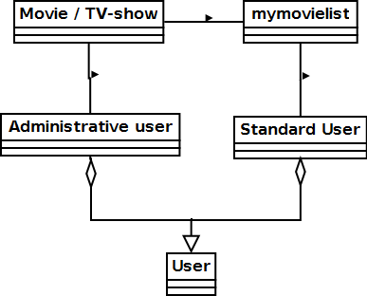
In the above class diagram, it is shown how administator and default user belongs to users, and how both administrator and users can access the information on a movies and TV-shows, but as the administrators job is only to change and add database info on movies and TV-shows, they do not affect the mymovielist, which is a list made by the user.

Actions
Actionstable is to show the actions that can occur from the five classes found in field of problems.
If a class has no actions, do not include in actionstable

Condition diagrams and attributes
Condition start – condition change – condition end

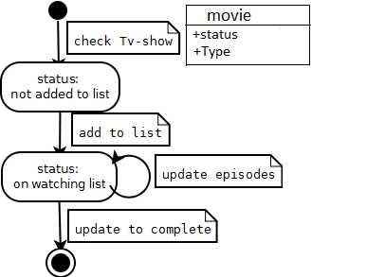
Conditions diagram for a movie
When a user visits a movie or tv-show info page for the first time, the status of it will be ”not add to list”, the user can then choose to add it to their list in any of the previously mentioned categories. Once this is done, the status on its page, will change to ”on X list”, showing the user that they have already added it to their list under the x category. The user can update number of episodes they have watched, or if a movie set it to 1/1 if they have seen it. If the user updates to complete, it is assumed they have watched everything of the show, and there cannot be added more episodes watched.
The first attribute on a movie and tv-show page is status, indicating whether or not the user has it on their list, what part of their list and whether or not they have completed it. The second is type, which shows up in search and helps users to see whether it is a movie or tv-show that they are opening a page with. This is important, as a movie and tv-show can have similar names.

Actor table
The actor table below gives an overview of 3 of the 5 classes found in the field of problem. In the table it is shown, We exclude the class users and the class movies. (more info later)
Action | Default user | Admin user
Create user | X
Delete user | X | X
Add movie to database |  | X
Add movie to list | X
Edit movie in database |  | X
Edit movie on list | X

Usage patterns
In usage patterns, we show how the web site will actually be used
go onto website – create user – login user – search movie – add series to list – end
go onto website – login user – go to list – change status of item on list - end

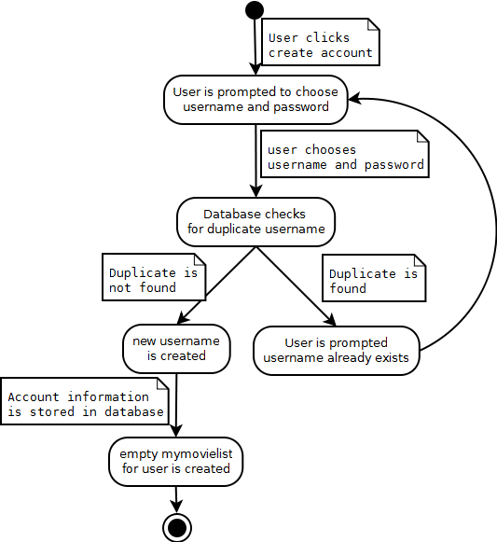
Usage pattern – create new user
When a visitor to the web site wishes to create a new user account, they are to click a create account link on the front page. When doing so, they are to be prompted to choose a username and password for the account. The user chooses these and the database checks for duplicates. If no duplicates are found, the new user account is created, its information is stored in the database and an empty mymovielist belonging to the user is created.
If there is already a user with the username, that the user typed in during the account creation, the databases check for duplicates will find it and the user will be show the text, that username already exists, acccount is not created and the user will have to choose another username and password.

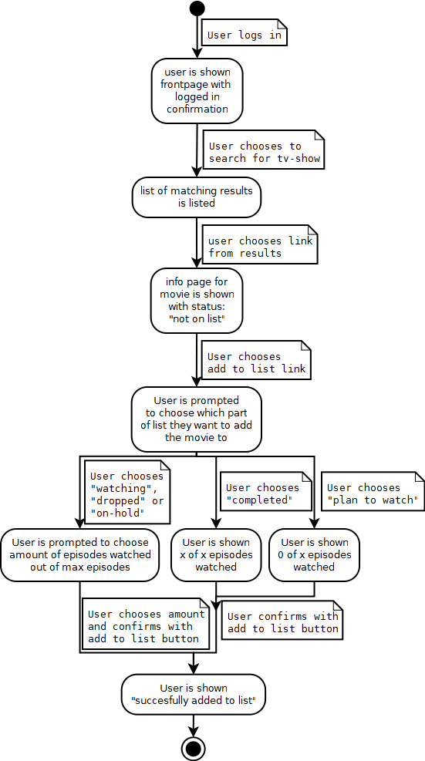
Usage pattern – add show to list
When a user wishes to add a movie or tv-show to a list, they are to start by searching for it, the web site searches in the database for matching and close to similar movie and tv-show names and then produces a list for with matches to the search. The user can then click the link of the correct match and be taken to the info page of the movie or tv-show.
Users can then use the ”add to list” button to start the process of adding it to their list. When they do so, they will have to choose which part of their list they wish to add it to; watching, dropped and on-hold will in many cases mean the user has seen some episodes of the tv-show they are adding, they are therefore given the choice to add the amount of episodes they have seen out of the total number of episodes in the series and only needs a confirmation of the choice.
If a user chooses completed, the web site automatically shows they have watched the total amount of episodes and like the previous mentioned choices needs this confirmed by the user, before adding it to their list.
If a user choosed plan to watch, the website will show 0 of total amount of episodes watched, the user then needs to confirm the choice.
Confirming the part of list a user wishes to add a show to is done by pressing the ”add to list” button. When a TV-show or movie has been added to the list, the user will get a confirmation status text with the sentence ”succesfully added to list” showing, where the add to list option previously was.

functions list
functions | functiontype | complexity
Register | update | Complex
User login | update | Simple
Add movie / tv-show to list | update | Medium
Edit item on list | update | Medium
Add episode watched | update | Simple
Edit number of episodes watched | update | Medium
Remove from list | update | Medium
Add movie /tv-show to database | update | Complex
Edit movie/tv-show info | update | Complex
Delete movie/tv-show | update | Complex
Mymovielist view | read | Simple
Movie / TV-show page | read | Simple
Functions on web page

Registation
Creating a new user requires some input by the user, which the database has to check for if is already existing. If the input username exists, the database and web site has to respond by not updating, but returning an error message, whereas if the username does not already exist, the database has to add the new username and the password to a table where they get an associated userID. As there is a lot of interaction with the database in creating a new user, it has been marked as a complex function.

Edit item on list
To edit a movie or tv-show on the list, a user will go to their list or to the page of the movie or TV-show they wish to update. If they choose to do it from their list, they will have to click an edit button, which brings up the options to change list placement, number of episodes watched or if they wish to remove the tv-show or movie from there list. The edit list placement function is considered of medium complexity, as it querys for info already existing in the database, which the user then changes.

Add movie or tv-show to database
When an administrator needs to add a new movie or tv-show to the database, it is an update of several tables. First off they need to find information on the movie or tv-show, detailing when it is made, by who, what year it is made, who is starring in it and last but not least find a synopsis for it.
If info on some of the previously mentioned types cannot be found, the admin cannot fill out the information and will therefore have to put in the Default in the field where the info should have been. By adding default, the database checks for what the default text is for the field and puts it there. By querying the table, the default text ”no synopsis yet” will show in the synopsis field for the movie where default was set as synopsis.
The admin will also have to update the character table, in which they will have to add the characters appearing in the movie, in this table, they have to set characterid's, character names, fill in character info and fill in info about what type of role they are playing. This needs to be added, so that people when viewing a movie on the webpage, can see what characters appear in the movie and if wanting more info on the character and what other shows they might star in, can click their name to do so.
Thereafter there is the people table, in which people starring in the show and associated with the movie may need to be added, if not already existing in it. To add a new person to this table, a personID, full name, birthdate and general biography information. Just like with the character table this is done to show who is staring in the movie and who is associated with it as staff or other important function.
Once all three tables have been filled out with this information, it needs to be associated with each other in the association table. So personID from people table are associated with characterID from character table and the same characterID is associated with movieID from movie table. All associations are given an assocationID, to ensure that the associations are unique.
Once this is done and the tables are updated, the new movie or tv-show with characters and people involved will be viewable on the movie or tv-shows page.

Edit movie / TV-show info
Editing information on a movie or tv-show involes opening one or more of the tables mentioned in the chapter above. Depending on what it is that one wants to change. Say a name of an actor had been misspelled, then you would use an UPDATE function in SQL, with the SET command specifying the field that needs its information changed, putting it equal to the actual information you want it changed to and the WHERE clause specifying the ID associated with the row.
Example:
UPDATE people
SET P_lastname ='Foxx'
Where P_ID = 1
The boxed example would in this database change Michael J Fox in the people tables’ last name to Foxx, as he has the P_ID 1
After updating it would in all movies starring him, say his name was Michael J Foxx.
This could also have to do with a person changing name at a later date and therefore needing a name change. and instead of going into every movie where Michael J Fox has a role, you would only need to update it in the people table.

Requirements for UI
Tasks | Requirements | Technology
-Routine tasks | Easy to learn  Easy to use  Fast to use | A sequence of functions?

The web site is going to have several functions, with most of them being meant to help users keep track of what they have watched on TV or in the cinema, the below mentioned are just some of these functions:
- Search for movies/tv-shows
- add them to list
- remove from list
- change place on list
- add episodes watched to list
These tasks which are to be done by users on the web site will be done repeatedly and are also routine. With this in mind and a wish to cater to a usergroup consisting of:
- users who are very experienced in use of the world wide web
- and users with little to no experience in the use of it
It is therefore important that the web site helps make the tasks fast and easy to learn and to use. This helps minimize the time needed for users learn the functions of the webpage and also helps reduce the time they need to spend on doing the tasks. (is the technology a sequence of functions?)

Navigations diagram
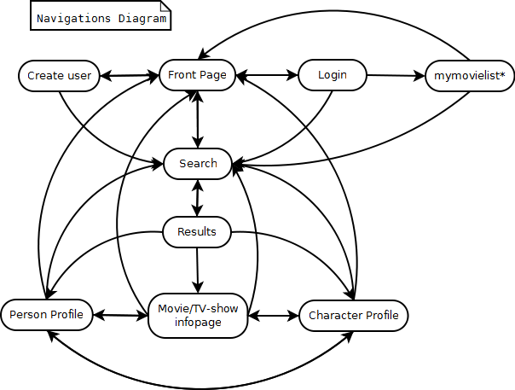
The Navigations diagram shows how a user gets around in the system.

Frontpage
It is the intention that visiting the webpages url, lands you on the front page. From the front page, the user can read about the latest updates of the web site and then also have the options to search or go to login or the create user screens.

Create new user
When visiting the create new user and the user has successfully created, they will then land back at the front page, where they will be logged in. If they wish to logout, they can do so where the login button previously was on the frontpage.

Login
If they already have a user, they can choose to login, which when done sends them to their movielist. The list can be accessed even when not logged in, however the user will then not be able to change information on it.

Search
The search function can be accessed from any page, as it is in the menu of the webpage. Using the search function, will bring up a list of results, from which the user can then click, to navigate on to a movie page, a (movie/TV-show associated person) profile or a character profile. The three different types of search results will also contain info about each other, it is therefore possible to visit each from one of the other two.

page illustrations
As a movie profile page and a personal list page will be some of the most frequented pages by the users, I have chosen to show illustrations of how these could look in the finished web site.

Movie profile
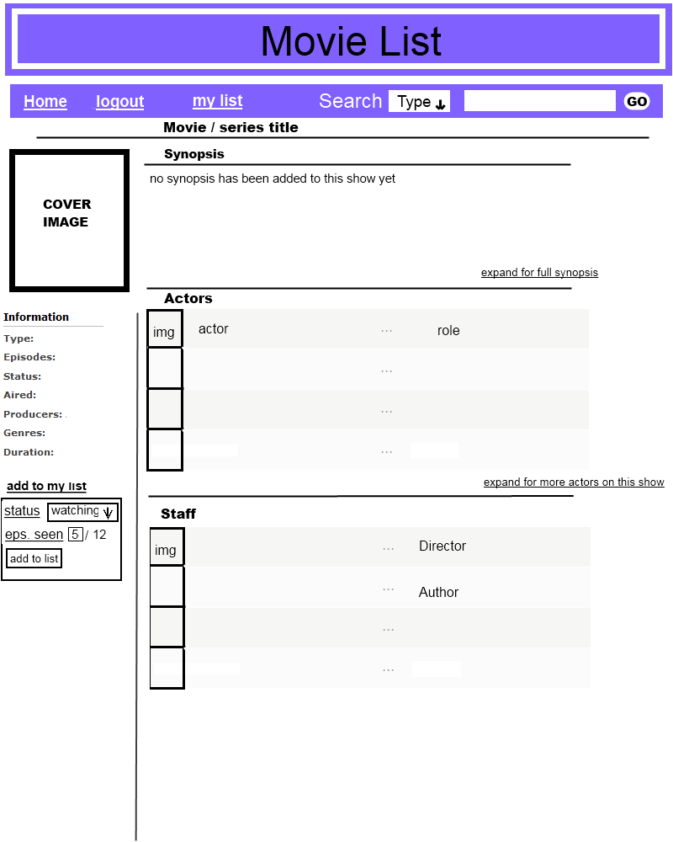
By looking at this page, it can be seen that the user will be adding to list in the left side of the window, while seeing synopsis, actors and their roles and staff members of movies in the right side. With this design, the first thing the users will notice, when viewing the page, will be a cover image for the tv-show or movie they are looking up info on. They will then notice movie title and synopsis for it just right of it. If the users continue reading the page, as you would normal text, from left to right, they should soon notice the general information for the show below the image, the list of actors in the show, the add show to list link, where they will fill in information, before adding it to their list and finally read the list of staff.
It is the intention that the user should notice the cover image and title as the first things when entering the page, this is seen as the most important information for the user, as it confirms that they are on the right page. They can thereafter check the general information and synopsis of the show, which is seen as the second most important information on the page, as it describes what it is they are looking at. After this they should notice the “add to my list” function, as this is seen as the third most important information. The least important information for a majority of users is suspected to be show/movie staff, as these do in most cases not directly show in the movie.

The users personal list
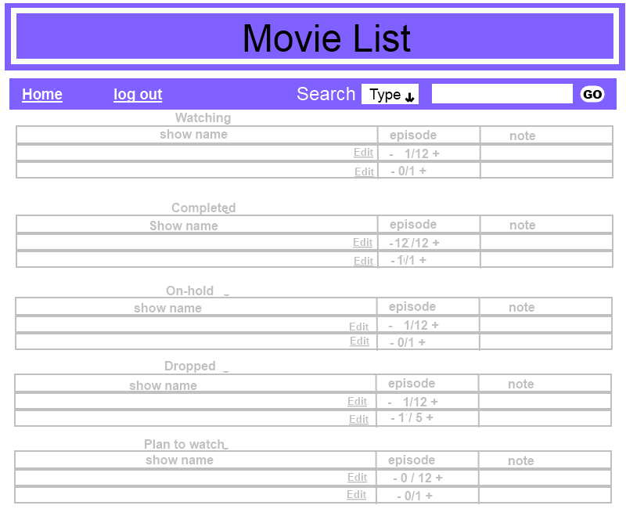
At the users list, they can see every TV-Show and Movie that they have added to their list. The watching list will be the most edited, as it deals with what the user is currently watching. This is followed by the list of completed, on-hold, dropped and the plan-to-watch list. It is the intention that the user be able to edit information on their list by using the edit button at the end of the title for a movie / TV-show. By clicking a +(plus) in the episode row, they can quickly add an episode watched and should they have made a mistake and added one or more episodes too many, they can click the -(minus) to subtract the number of episodes they have watched. In the current version, the list will not automatically switch a movie to completed, the user is supposed to do this with the edit button.

Design criteria
Criteria | Irrelevant | Less Important | Important | Very Important
Useful |  |  |  | X
Understandable |  |  |  | X
Flexibility |  |  |  | X
Correct |  |  | X
Safe |  |  | X
Effective |  |  |  | X
If made into a full scale web site, containing thousands of movies and TV-shows and thousands of users, this can easily become an enormous task to handle for a single developer, it is therefore important that the web site and its database be easy to understand and flexible by design, so that if more developers do coding for it, they can easily figure out how to build upon it. As mentioned, a web site like this can have many thousands of users, who will be using it both to make personal lists and to look up information on movies, TV-shows, actors, characters and staff production, it is important that the web site is effective to use and the design be useful in helping them do these tasks.
Safety on the web site is also important. Even if the current version does not hold much information about the user, many would be saddened, if others could edit their lists, thereby possibly destroying an information, tracking and management resource of a user. Losing this will not only be bad for the users, but might also draw discredit towards the web site, for not protecting the users information. It is therefore important that there be none other than the owner of a list that can change contents on it.

Design Components
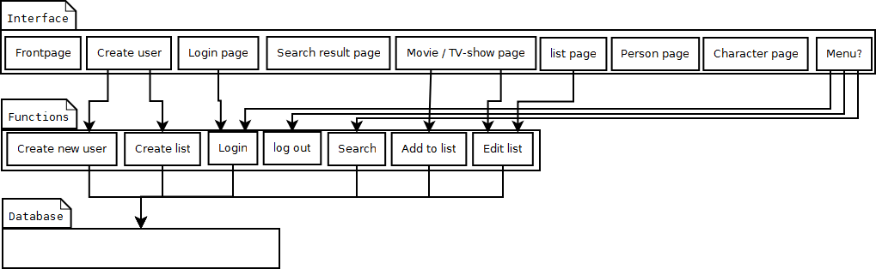
In the above image can be seen the architecture of the components of the web site, in the pattern of the ground architecture. It shows how interfaces of the web sites pages each have functions assigned to them and how all but the log out function accesses the database for information, whereas the log out simply makes the user unable to edit their list.

design

Stakeholders
As the web site is going to be for public use, anyone wanting an online way to track their progress with and time spent watching tv-shows and movies, is to be able to use it. With an interest in getting the web site to have updated information on TV-shows and movies, and as many as possible making and managing their personal list on the web site.
When considering this, there will need to be several people helping the website to work as intended.These include administrators who will be the primary stakeholders, as they continuously have to update and add information to the web site. Secondly there will be needed someone to supply the information, which is to be added to the web site. Secondary stakeholders can therefore be these suppliers, who will also be users of the web site.
With this said, having to run a web site, that will be visited by thousands of people per day, will not be costless. Serverspace for all the information, server power to handle the many requests and high upload speed, to handle sending information back to the users will all be costy. Because of this there will be needed a source of income to pay for these services being supplied to the web site.
The easiest way to generate income for a web site, will be commercials. To get commercial income, there will need to be someone paying for the commercials. These people are also suppliers to the website and can therefore be considered (secondary or tertiary?) stakeholders for the web site.
Commercial income is an easy option, but not always wanted, as commercials can be an annoyance for users. Another option can therefore be to have the web site sponsored by sources of interest. Film companies who in turn for sponsoring gets supplied with user data, anonymous or not, can therefore be seen as another potential source of income, and as they get something in return for sponsoring, they would also be seen as a stakeholder(but what level?).

Personas
As we already described earlier in the report, how an admin will add and edit in new titles, people and characters in the database, I will describe only personas that are users of the web site and should show how certain functions of the web page work.

Persona 1
Ben Johnson is 19, is in high-school and in his sparetime he works in a video store. His job consists of the sale and rental of dvd's and blu-rays, while also assisting customers in the store in finding the movies and tv-shows they're looking for. Ben originally started working there because of two things: 1) the payment was good for simple work and 2) because he can get a discount on older dvd's and blu-rays. Because of the discount, Ben likes to buy a lot of movies and tv-shows too, many of which he never takes or gets the time to watch as he tends to prioritize homework first, computer gaming second and TV as third. Because of this, the DVD's and blu-rays he purchases, simply amass in his appartment and aren't getting. He swears though that he will get around to watching them some day, but simply always forgets that he actually bought them.
Therefore when Ben heard of mymovielist, he found it a perfect opportunity to catalog the DVD's and blu-rays he owns. With mymovielist, Ben no longer needs to keep a mental track of what movies and tv-shows he has purchased and had started watching, completed and planned to watch some time in the future, he can simply use the list for it. As the list is online, he neither has the chance of accidently deleting a document containing the list of things he has watched.
Bens experience with IT is fairly high, he has a desktop computer at home, which he uses for homework, gaming and surfing the web and so is quite familiar with both well made and less than well made interfaces, both on web sites and in programs.

Persona 2
Rena Hansen is 45, a family mother of 5 and works at a local super market. In her sparetime Rena, enjoys shopping secondhand online, spending time and watching TV with the family and also spending time with friends. While checking one of the websites she shops on, she recently saw an ad banner for mymovielist and by clicking it, learned of what the web site is about. With the information pasted on the about page on the web site, she figured it could be fun to make a list for herself, and get her friends to do the same. She wants to use the list as a personal tracker of what she is watching, while also using it as a topic conversation helper, when with her friends.

Scenarios

Usability

Effectiveness

Efficiency

Generate design

Use case

interactionsspace

implementation
Cannot be done till more php knowledge

system realization
Need more php knowledge

discussion

Conclusion

Litterature list

